Regina Biathlon Club
Emergency Action Plan

What do I do?
1. Dial 9-1-1
2. Location – Regina Wildlife Federation
3. GPS: 50 28.095 N 104 23.101 W
4. Send someone to meet EMS at gate, and to direct them to location.
*Make sure this person has gate card*
5. Tell 9-1-1 Operator
a. What happened
b. Approximate age of victim
c. Gender of victim
d. Location of victim – trail, range, etc.
e. Medical information – type of injury, symptoms, etc.
f. What first aid has been given
6. First aider to stay with victim (reassure victim and keep warm)
7. Confirm someone to take EMS to victim or take victim to EMS
8. DO NOT talk to media – RWF and/or RBC Representative will handle
9. Contact victims family

If victim is out on the trail either they will need to be moved to clubhouse or transport for EMS to victim will need to be arranged, inform EMS if known at time of first call.
There is a toboggan in the shed and a first aid kit, blankets and splint in the warm up shack.,
First aid kit also in RWF women’s washroom.
Regina Biathlon Club
Emergency Action Plan

Directions and Location
Club Location: Regina Wildlife Federation
GPS: 50 28.095 N 104 23.101 W
Directions from Regina: Drive east on Hwy #1 to White City bypass. Turn right off highway up to bypass then turn left (north) crossing over highway and continue driving to the stop sign. Turn left (west) on to service road and continue approx. half a kilometer to the Stone Pointe estates sign then turn right (north). Continue approx. 1.9 kilometres then turn right (east) onto Regina Wildlife Federation grounds.
Entry through electronic gate, club member should be there for access and to guide EMS to location on grounds. Drive east past dome shaped building and take a left hard turn, follow road around until you are at the last building.
Hospital: Regina General Hospital – 1440 14th Ave. phone number: 306-766-4444
Return to Hwy #1 follow west bound into Regina, turns into Victoria Ave., stay on Victoria Ave. Continue to Toronto St. and turn left (south) follow signs to General Hospital Emergency.

Club Contacts:

Regina Biathlon Club
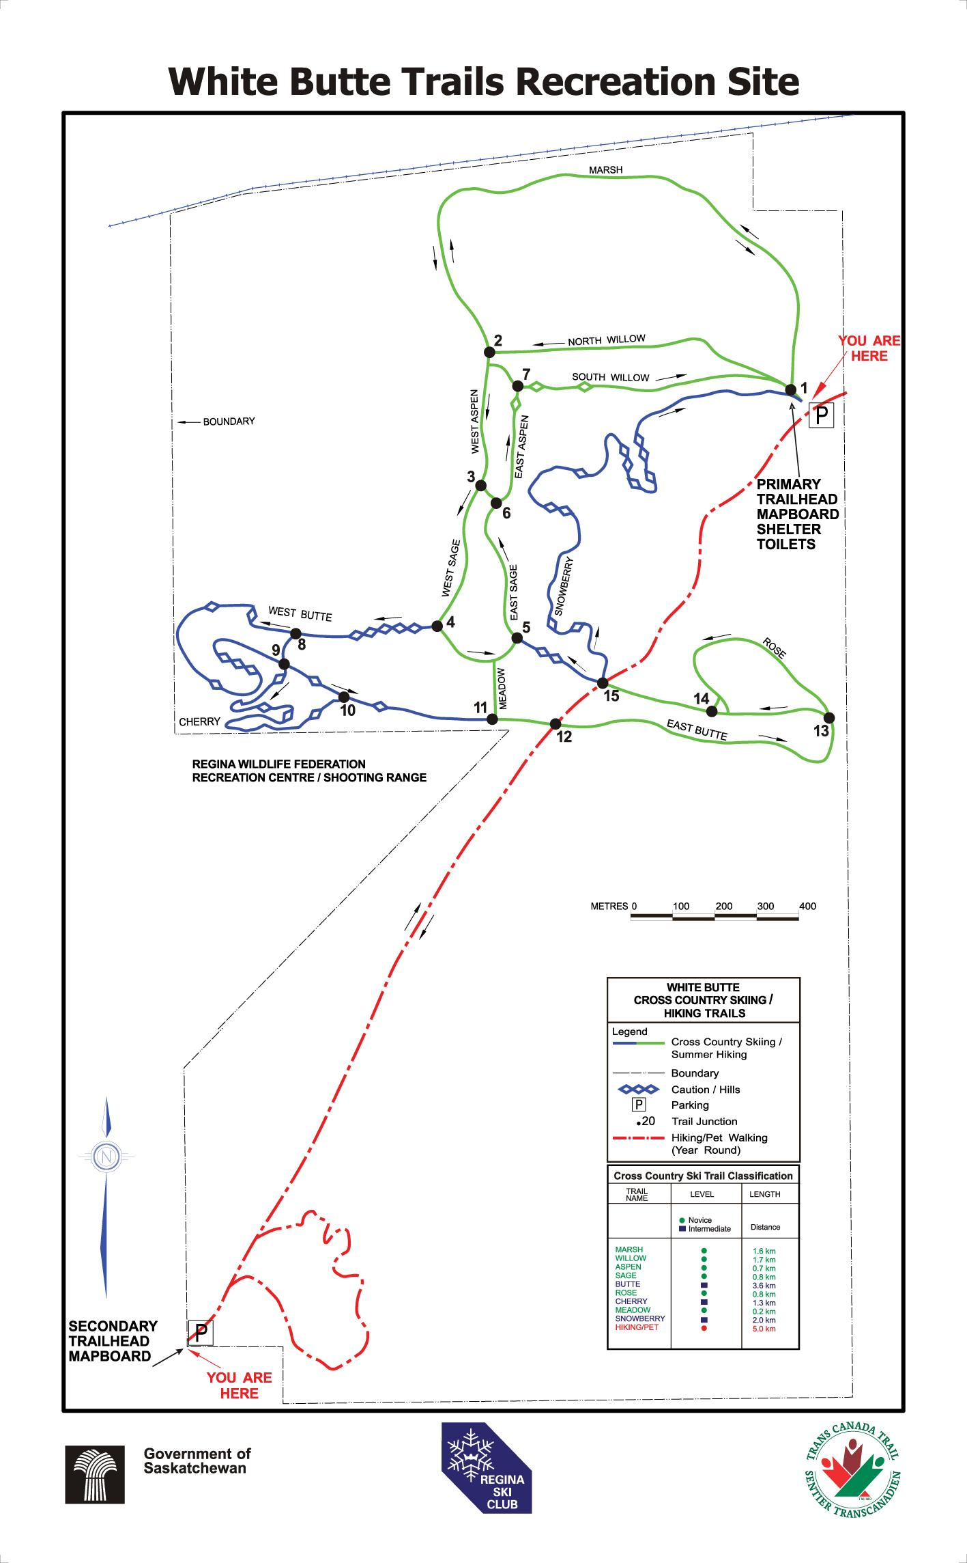
Emergency Action Plan

Regina Biathlon Club
Emergency Action Plan

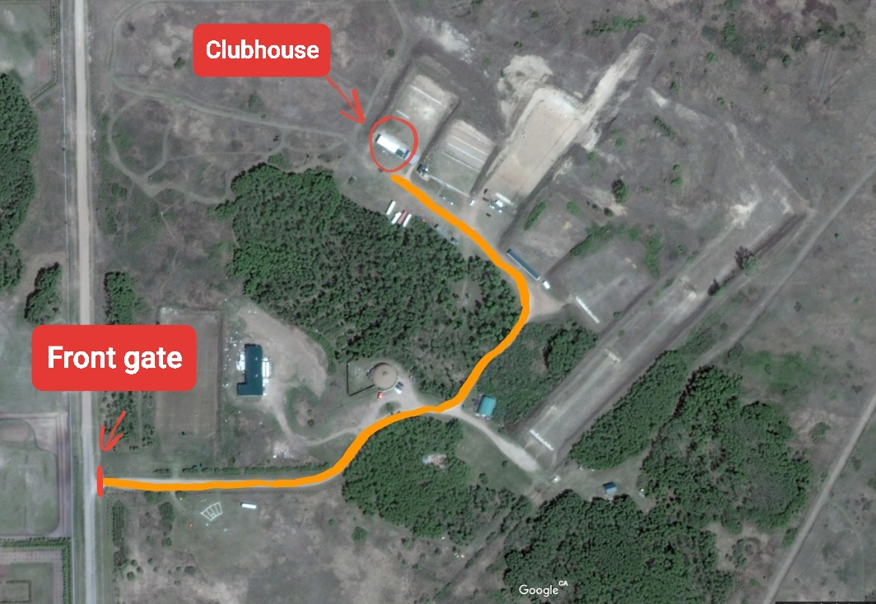
Directions from Front Gate to Clubhouse

Regina Biathlon Club
Emergency Action Plan

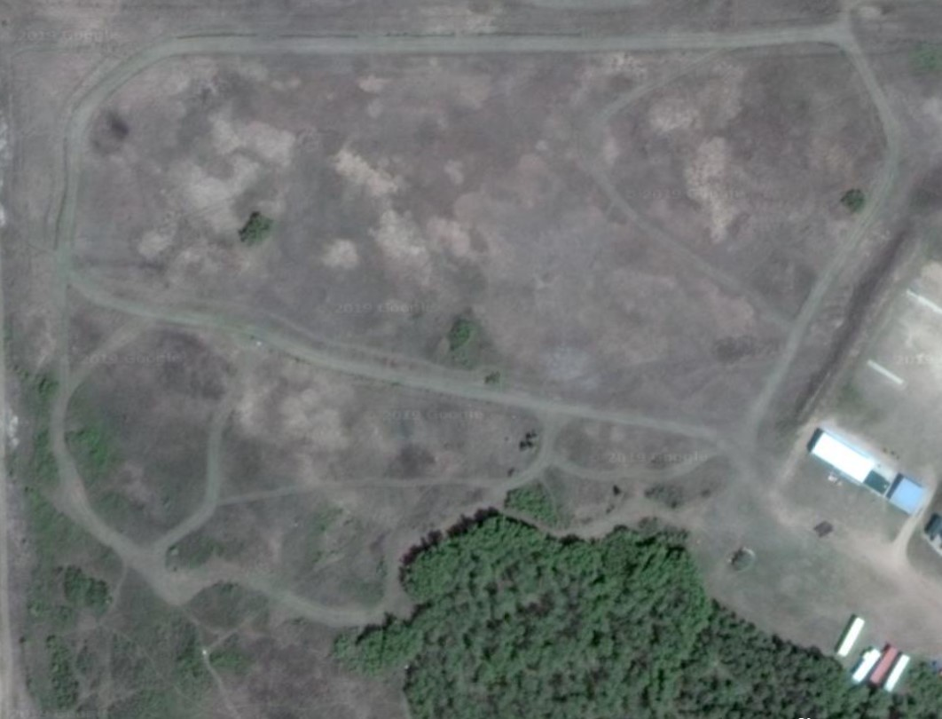
Map of Regina Wildlife Federation Trails

